Seamus Moore

technical documentation

**Technical Documentation**

**Title of Project, Author & Date Submitted:**

The website is called *Canvas Corner* which is an art website. This is named this way because it is what the client requested as it is the current name of her business. The author is Seamus Moore, a year 12 student from Port Moresby International School. The final version of this project was submitted to the client on the ...

**Name of Client/User and Nature of Business:**

The client is one person; Jane Moore. The client is just a person that wanted a simple website to showcase theirs and others art creations. Jane Moore wanted this website because they required a simple website that was easy to use and navigate for her art.

**Purpose or Objective(s) of the System:**

The purpose of the system is showcase the client’s art and provide information on upcoming art classes. The website’s main objective is to communicate information clearly and effectively, so that anyone can understand what they’re reading with ease. The website aims to provide information easily and efficiently for the everyday user and for those that are new to websites.

**Final Timetable for the Project:**

|  |  |  |  |  |  |  |  |  |  |  |  |
| --- | --- | --- | --- | --- | --- | --- | --- | --- | --- | --- | --- |
| **Activity** | **Term 3** | | | | | | | | | | **Term 4** |
|  | 1 | 2 | 3 | 4 | 5 | 6 | 7 | 8 | 9 | 10 | 1 |
| Written Proposal |  |  |  |  |  |  |  |  |  |  |  |
| Fact-Finding |  |  |  |  |  |  |  |  |  |  |  |
| Analysis |  |  |  |  |  |  |  |  |  |  |  |
| Design & Development |  |  |  |  |  |  |  |  |  |  |  |
| Testing |  |  |  |  |  |  |  |  |  |  |  |
| Evaluation |  |  |  |  |  |  |  |  |  |  |  |
| Documentation |  |  |  |  |  |  |  |  |  |  |  |
| Presentation |  |  |  |  |  |  |  |  |  |  |  |

A revised timetable (Gantt chart) is shown below.

**Project Design:**

**Hardware and Software used**

A laptop running Windows 8.1 and a computer at school running Windows 7 Professional was also used to design and create the website. I used Notepad ++ to write some basic code and make basic changes. I used Visual Studio to write the website layout and pages, as well as the dropdown menu and the image gallery. I also used Visual Studio and Notepad ++ to create the CSS files. Software able to access the internet such as Google Chrome was used to source images for the website and to test the websites functionality throughout the development. Some images were also sourced from the client as well as some of the text she wanted to be displayed on her website. I used Microsoft Word to type up the documentation and all the other relevant documents that were needed.

**Design (Site Map)**

Site Map Contents:

* Home
* Contact US
* Who are we?
* Gallery
  + Session 1
  + Session 2
  + Session 3

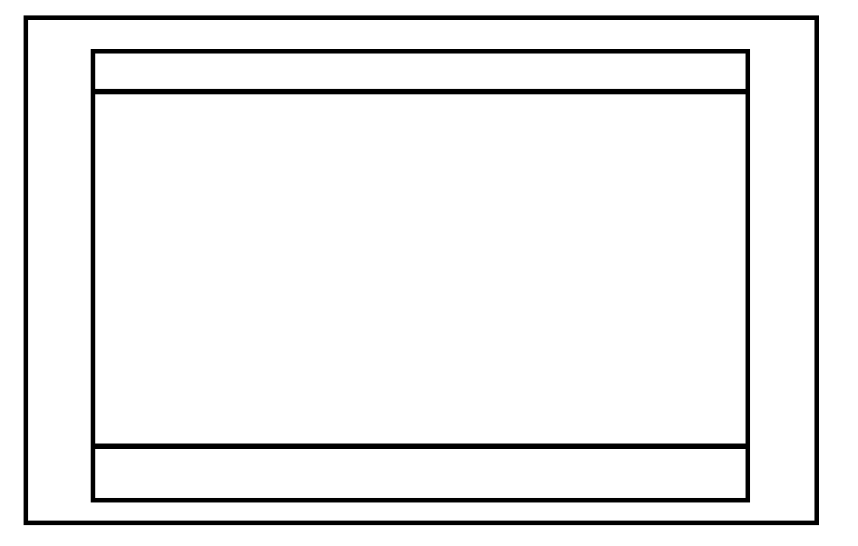A wire frame for base CSS layout of all the webpages can also be found below.

Website background which is set to fixed and doesn’t change.

Site container which has a set max-width of 12000px. Site container also changes size upon browser size change. Navbar and site footer are also both based off site container defined sizes.

Site footer which also has a set max-width of 12000px. Site footer also changes size upon browser size change.

Navbar which is made up of a variety of different CSS attributes which can be found in the corecss file, as it uses a mobile navbar or a desktop navbar depending on screen size which is controlled by @media css’.

**Design Narrative –** The design of this project revolved around the use of three main colours: blue, purple and light grey. The header and background colour are dark blue, which creates a healthy contrast from the light grey of the body. The body isn’t white because complete and hard white is more eye-straining, whereas the shade of grey used is softer on the brain. The text is primarily black to contrast from the body colour. The links are a reddish-pink to catch the user’s eye and ensure they don’t miss it. The heading and subheading text is purple; to compliment the colour of the blue parts of the website. Purple is also a really nice colour. Lastly, the navigation menu is a light blue, which sets it apart from the header and wrapper and makes it more eye-catching. The text inside the navigation menu is white, to make the interface look cleaner and more modern.

The page and text layout matches the common page layout of English-speaking countries (left to right, moving downwards). There is also a text indent in the page, to separate the text from the dark colours of the background. The font I used was Arial, Helvetica from sans-serif. This is because the font is commonly used and very easy to read.

I used several advanced techniques while creating the website. In order to create a body with a gap on both sides showing the background and indents to separate the text from the wrapper, I had to create a table that had transparent and blank columns. This was quite difficult, as I had to create a class that contained transparent properties. This is what made gaps that show the background behind the body. The text indent was created by using a class that made the columns blank.

Another technique was making the drop down navigation menu. This menu doesn’t use any JavaScript, and neither does the rest of the website. The navigation menu is purely CSS, and it proved to be challenging to create. The result, however, is faster load times and a clean-looking menu.

**Testing and Implementation:**

*Beta Testing Questionnaire included in project documentation*

*Beta Testing Questionnaires (Completed) attached*

There were several beta testers for this project, all of whom were aged between 18 – 50 years old. The first one is Ryan Ellis (one of the clients). I had Mr Ellis test the website in this stage to ensure that the product was the desired one, and to give him a more complete idea on the product he was getting. Another beta tester is Ronan Moore. Mr Moore is a teacher at Port Moresby International School, and the Head of Department for English. I had him test the links of the website, as well as the spelling, use of grammar and syntax. The last beta tester is Veronica Ygoña, a first-year university student in the Philippines doing a course in Development Studies. I believe she was qualified to test the site because she represents the group of people who know nothing about computer hardware. She tested the site to ensure that the information was easy to understand, and her returned beta questionnaire form confirms this.

One of the beta testers, Ryan Ellis, didn’t really like how there was so many blank white/grey spaces. He told me he wouldn’t really know how a little issue like that could be fixed, but I altered the text to see if it would change anything. After changing increasing the text size by 4 points, all the body text on the website looked larger and made the website seem fuller. This created a balance between the black body text and the blank spaces, and therefore I believe this problem to be solved.

**Assessment of Social Significance of Product:**

The client almost immediately reaped the benefits of using the website. When in a Skype call with the client while he was testing the website, he learned that case fans do not interfere with CPU fans, and that there are multiple types of water cooling. That was only one of the many notable realisations the client made.

This website has an extremely broad social reach, as the information can be used and applied by anyone who wishes to learn more about computer hardware. This means that the website can be used by more people than just the client. Due to the fact that the website’s information is relevant to everyone interested in computers, the context of the information doesn’t need to be changed in order for it to make sense. There are many situations where the product would be useful to people other than the client; like, for example, if an IT student needs to study for a test but can’t make sense of a lot of the information they were given.

**Samples of Webpages and Data:**

A sample of the contact us page (screenshot):

A sample of one of the gallery pages (screenshot):

An excerpt of some text from the home page:

“Wear something that you feel comfortable in preferably something you don’t mind getting a little bit of paint on – just in case! We encourage you to put your own personalised touches into your artwork. You are free to change the colours, the shapes, or paint your own original design.”